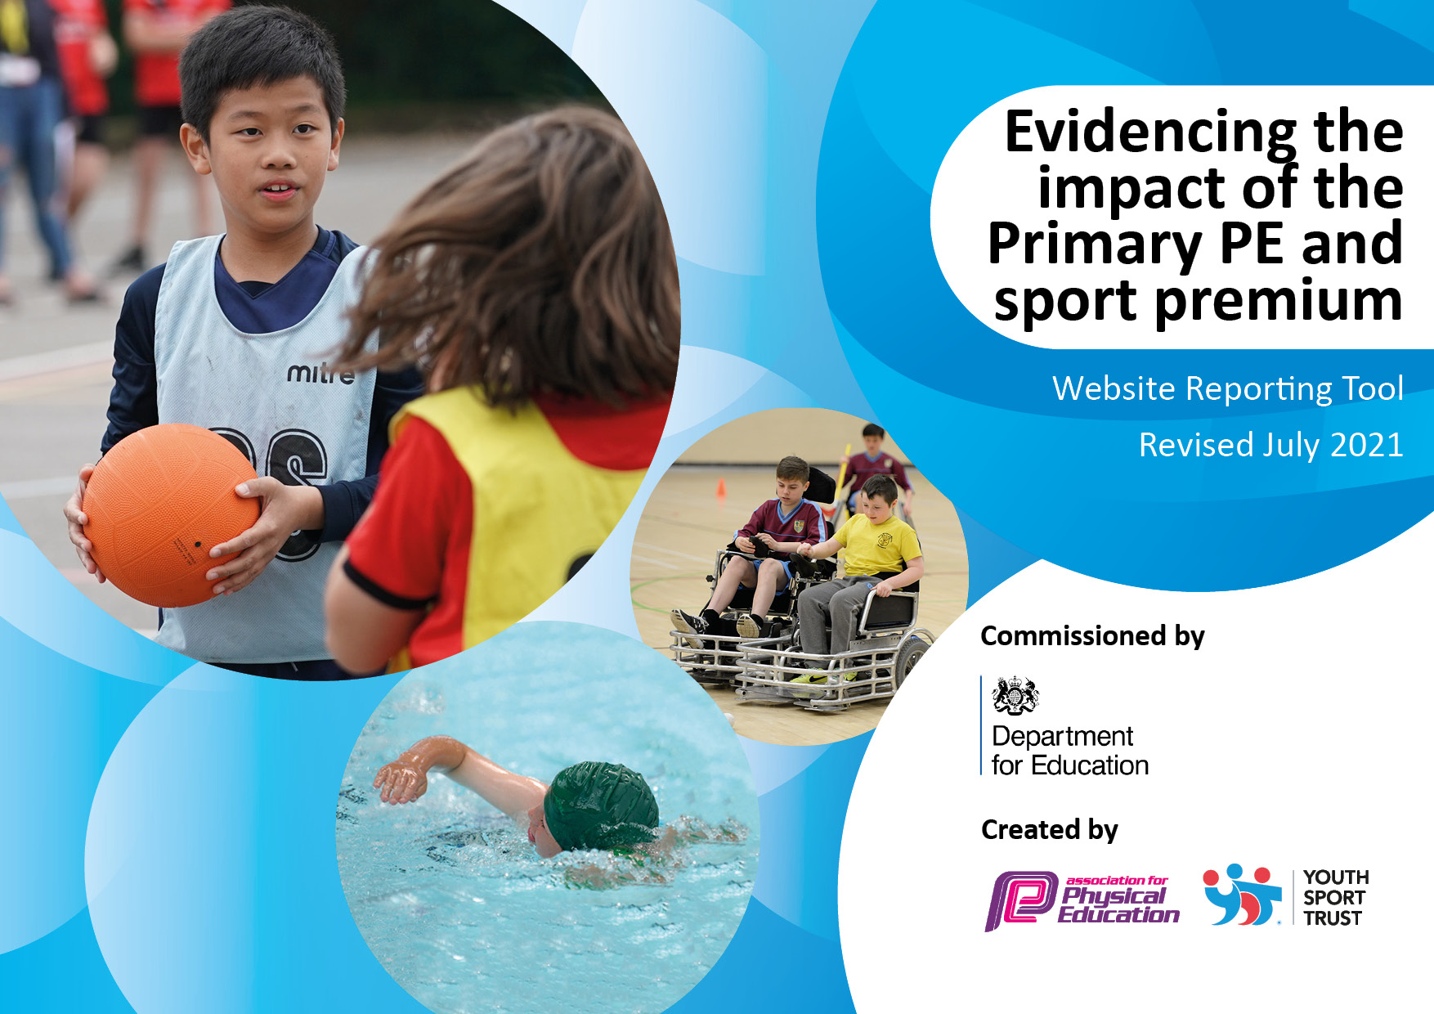
River Mead School, Melksham
2022-23
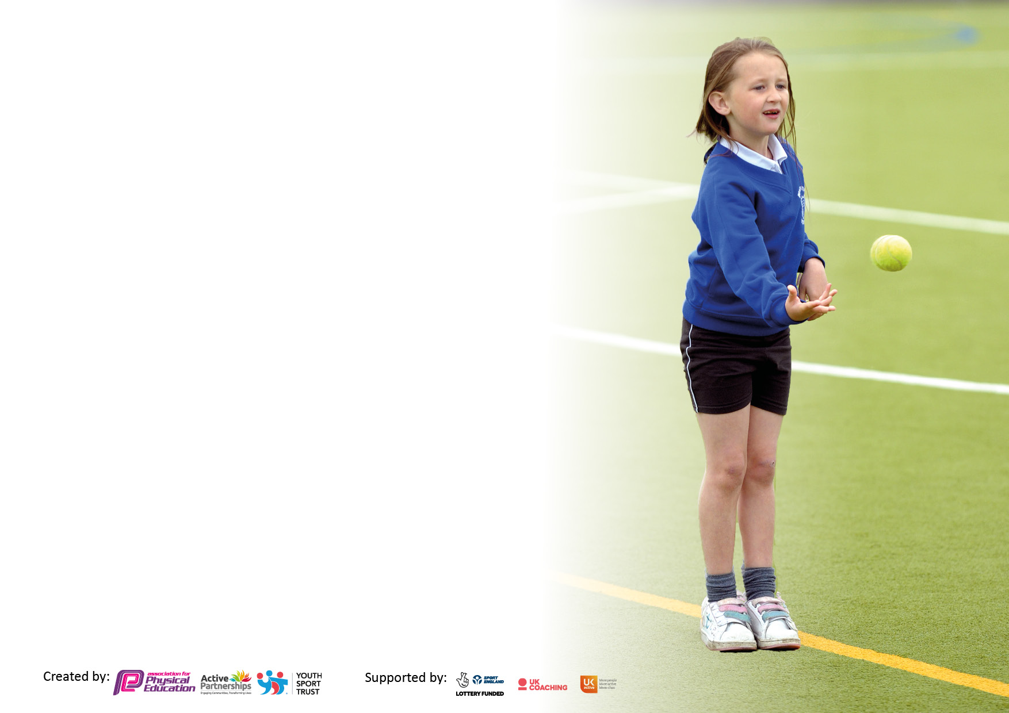

It is important that your grant is used effectively and based on school need. The Education Inspection Framework makes clear there will be a focus on ‘whether leaders and those responsible for governors all understand their respective roles and perform these in a way that enhances the effectiveness of the school’.

Under the Quality of Education Ofsted inspectors consider:
Intent - Curriculum design, coverage and appropriateness
Implementation - Curriculum delivery, Teaching (pedagogy) and Assessment
Impact - Attainment and progress

To assist schools with common transferable language this template has been developed to utilise the same three headings which should make your plans easily transferable between working documents.

Schools must use the funding to make additional and sustainable improvements to the quality of Physical Education, School Sport and Physical Activity (PESSPA) they offer. This means that you should use the Primary PE and sport premium to:

- Develop or add to the PESSPA activities that your school already offer
- Build capacity and capability within the school to ensure that improvements made now will benefit pupils joining the school in future years
- The Primary PE and sport premium should not be used to fund capital spend projects; the school’s budget should fund these.

Pleasevisitgov.ukfortherevisedDfEguidanceincludingthe5keyindicatorsacrosswhichschoolsshoulddemonstrate animprovement.Thisdocumentwillhelpyoutoreviewyourprovisionandtoreportyourspend.DfEencouragesschools to use this template as an effective way of meeting the reporting requirements of the Primary PE and sport premium.

We recommend you start by reflecting on the impact of current provision and reviewing the previous spend.

Schools are required to publish details of how they spend this funding, including any under-spend from 2019/2020, as well as on the impact it has on pupils’ PE and sport participation and attainment. All funding must be spent by 31st July 2022.

We recommend regularly updating the table and publishing it on your website throughout the year. This evidences your ongoing self-evaluation of how you are using the funding to secure maximum, sustainable impact. Final copy must be posted on your website by the end of the academic year and no later than the 31st July 2021. To see an example of how to complete the table please click HERE.
Created by: Supported by:

Details with regard to funding
Please complete the table below.

Total amount carried over from 21/22 | £0
Total amount allocated for 2021/22 | £17,800
How much (if any) do you intend to carry over from this total fund into 2022/23? | £0
Total amount allocated for 2022/23 | £17,840
Total amount of funding for 2022/23. To be spent and reported on by 31st July 2023. | £ 17,840
Swimming Data
Please report on your Swimming Data below.

Meeting national curriculum requirements for swimming and water safety.  N.B. Complete this section to your best ability. For example you might have practised safe self-rescue techniques on dry land which you can then transfer to the pool when school swimming restarts.  Due to exceptional circumstances priority should be given to ensuring that pupils can perform safe self rescue even if they do not fully meet the first two requirements of the NC programme of study | 8/2  This was affected by COVID and access to local swimming pool.
What percentage of your current Year 6 cohort swim competently, confidently and proficiently over a distance of at least 25 metres?  N.B. Even though your pupils may swim in another year please report on their attainment on leaving primary school at the end of the summer term 2023.  Please see note above | Rebuild of local pool meant not able to source affordable option to complete. Additional swimming for Y5 and Y6 who have been prioritised in 2022-23.  Current Y6 did attend some limited swimming lessons as Y3 in 2019-20 before start of pandemic.
What percentage of your current Year 6 cohort use a range of strokes effectively [for example, front crawl, backstroke and breaststroke]?
Please see note above
What percentage of your current Year 6 cohort perform safe self-rescue in different water-based situations?
Schools can choose to use the Primary PE and sport premium to provide additional provision for swimming but this must be for activity over and above the national curriculum requirements. Have you used it in this way? | No

Action Plan and Budget Tracking
Capture your intended annual spend against the 5 key indicators. Clarify the success criteria and evidence of impact that you intend to measure to evaluate for pupils today and for the future.

Academic Year: 2020/21 | Total fund allocated: | Date Updated:
Key indicator 1: The engagement of all pupils in regular physical activity – Chief Medical Officers guidelines recommend that primary school pupils undertake at least 30 minutes of physical activity a day in school |  |  |  | Percentage of total allocation:
 |  |  |  | %
Intent | Implementation |  | Impact
Your school focus should be clear what you want the pupils to know and be able to do and about  what they need to learn and to  consolidate through practice: | Make sure your actions to achieve are linked to your intentions: | Funding allocated: | Evidence of impact: what do pupils now know and what can they now do? What has changed?: | Sustainability and suggested next steps:
Regular physical activity will be a routine in the daily lives of children. | PE lessons:  - PE Specialists to teach PE to each class weekly focusing on physical skills, competing skills, learning how to be healthy and developing performance.  - P.E. curriculum focuses on Fundamental Movement Skills (FMS) in KS1 and adapting these to sports in KS2 so has a big focus on being physically active.  - Support the quality improvement of EYS learning environments and opportunities provided to enable children to develop their core strength, stability, balance, spatial awareness, co-ordination and agility.  Playtimes and Lunchtimes:  - Kingfisher court open at lunchtimes to provide sporting opportunities for the children.  - Activities are staffed and being progressively resourced.  - Play leaders in Y6 assisting on the playground with a number of activities.  After School Clubs  - Reintroduce after school clubs that focus on giving all children a broad opportunity to be engaged in a range of sports and physical activities.  - Run by teaching staff and P.E. specialist.  - Planned and resourced with support of the PE lead.  Resources and environment:  - Audit P.E. equipment and ensure it is well stocked and in good safe order. Re-order where necessary across both sites.  - Ensure the PE environment is safe and in good working order (e.g. hall, kingfisher court, playground) | - Time to up skill teachers in ‘Phys’.  - Cost of P.E. specialists.  - Cost of teachers/TA/PE Specialist.  - Cost of resources. | - Pupil interviews.  - Lesson observations.  - Pupil voice- Sports Family.  - Children engaged in more physical activity.  - Children enjoying physical activity.  - Greater opportunities to participate. | - More play leaders going through the Wiltshire Council training.  - Families and staff engaged in physical activity.
Key indicator 2: The profile of PESSPA being raised across the school as a tool for whole school improvement |  |  |  | Percentage of total allocation:
 |  |  |  | %
Intent | Implementation |  | Impact
Your school focus should be clear what you want the pupils to know and be able to do and about  what they need to learn and to  consolidate through practice: | Make sure your actions to achieve are linked to your intentions: | Funding allocated: | Evidence of impact: what do pupils now know and what can they now do? What has changed?: | Sustainability and suggested next steps:
Attainment and progress is enhanced across the curriculum as a result of children being more physical activity.  Impact on their spiritual, moral, social and cultural understanding. | - Regular activity imbedded across the school. See above strategies.  - More P.E. links to Science, PSHE, Speaking and Listening, IT, Maths.  - Develop ways of measuring the monitoring levels of physical activity and progress in the curriculum  - Curriculum planning is covering diversity and ‘stand out figures of their time’ PE will also have this to present key figures in all sports.  - Behaviour learned through the PE curriculum (fair pay, sportsmanship etc.) applied across the whole curriculum.  - Promote awareness of health related issues e.g. obesity, smoking etc.  - Children as leaders e.g. Young Leaders, Sports Council, Youth Ambassadors, Sports Family.  - Show a range of sporting role models from all different backgrounds. Using Olympic and Paralympic athletes as focusing. | - Time to up skill teachers.  - Cost of P.E. specialists to run these.  - Cost for resources based on stand out figures.  - Cost of P.E. specialists. | - Achievement is improved through SATs results.  - Pupil voice and Pupil interviews  - Concentration, commitment, self-esteem and behaviour are enhanced  - The profile of sport is raised so that all children are involved in some aspect of healthy living or fitness.  - Children understand the positive impact of physical activity on their wider learning.  - Staff make links between PE and other subjects across the curriculum.  - Positive behaviour and sense of fair play are enhanced. | - Other Subject leaders to identify how their subject areas can contribute to learning in PE and vice versa.  - Link to history timelines and significant events in sport history.

Key indicator 3: Increased confidence, knowledge and skills of all staff in teaching PE and sport |  |  |  | Percentage of total allocation:
 |  |  |  | %
Intent | Implementation |  | Impact
Your school focus should be clear | Make sure your actions to | Funding | Evidence of impact: what do | Sustainability and suggested
what you want the pupils to know | achieve are linked to your | allocated: | pupils now know and what | next steps:
and be able to do and about | intentions: |  | can they now do? What has
what they need to learn and to |  |  | changed?:
consolidate through practice:
Trust-wide cohesion with a focus on sharing good practice in use of the new P.E. curriculum, planning and assessment. | P.E. curriculum:  - Has been written by Trust P.E. lead based on research and used with success last year.  - Main focuses are:  1: Fundamental Movement Skills  2: Sports (participation, tactics and knowledge of rules and role models)  3: Social and Personal Skills  - Sportsmanship  - Self-improvement,  - Leadership  - learned about health and fitness  - anatomy and the science of sport  - LTP to be created by Mr Smith for 2022-23 to ensure that all skills are coved across the year.  - Resources ordered to ensure successful delivery  - Use the new Statutory framework for the early years foundation stage to support colleagues in YN, R, 1 and 2 in areas such as gross and fine motor to support early physical development. This is particular relevant for our children after lockdown- we need to find ways to allow children to explore movement. P.E. leads to adapt the progressive curriculum to incorporate these changes.  - Outdoor and adventures curriculum (the sequential offer of provision in each year group in order to develop skills and confident progressively. This also needs to be linked to topics and opportunities in the local area.  Assessment:  - Has been written by P.E. specialist based on the curriculum.  - Needs some development around the understanding of what makes ‘greater depth’ and ‘working towards’.  - Monitor/track children’s progress and do data analysis- disadvantaged, GAT, boys/girls.  - Develop use of assessment to target children who need support in certain areas of the curriculum.  - Fitness levels assessment established and monitored with support for those children struggling.  - P.E. specialist support Class Teachers making judgments for annual reports.  P.E leads meetings:  - Termly Trust-wide meetings.  - Attend PE Conference and CSL meetings.  CPD:  - P.E. leads to support Class Teachers in delivering and assessing skills based P.E. and Daily 15.  - CPD training for teachers on their weaker areas e.g. gymnastics.  - Termly check-ins and observations/Learning Walks.  - CPD needs identified and sought within the Trust and Trowbridge collaborative.  P.E. lead:  - Keep up to date with Ofsted reports and government documents and disseminate any relevant information to the rest of the Trust.  - Monitor planning. | - Cost of P.E. specialists to deliver curriculum.  - Cost of upskilling the PE lead in the new EYFS framework.  - Cost of P.E. lead to develop and to train PE TA to use. | - Discussions with staff and staff survey.  - Teachers feel more confident in teaching P.E. and promote a range of sporting activities.  - Teacher subject knowledge and skills are improved.  - Subject leader demonstrates knowledge of subject standards and EYFS framework.  - Quality of provision is enhanced.  - Best practice is recognised and shared | - Adapt the current and edit the current curriculum to align with visions of new PE staff.
Key indicator 4: Broader experience of a range of sports and activities offered to all pupils |  |  |  | Percentage of total allocation:
Intent | Implementation |  | Impact
Your school focus should be clear | Make sure your actions to | Funding | Evidence of impact: what do | Sustainability and suggested
what you want the pupils to know | achieve are linked to your | allocated: | pupils now know and what | next steps:
and be able to do and about | intentions: |  | can they now do? What has
what they need to learn and to |  |  | changed?:
consolidate through practice:
Provide a rich curriculum and extra-curricular activities that supports children’s development and interests. | Extra-curricular:  - Intra-trust sporting competitions reintroduced face-to-face.  - Participation in Wiltshire School Games were appropriate.  - Pay for West Wiltshire Partnership Sport Provision.  Review the quality of our P.E. curriculum:  - The P.E. curriculum is inclusive and is designed to inspire and engage all pupils.  - Gauge pupil needs/interest – Sports Council, PE specialists, pupil interviews.  - LTP ensures that all skills are covered throughout the year.  - Our core principals are taught through a range of sports and activities.  - Opportunities to extend and develop talents are embedded.  - Use the new Statutory framework for the early years foundation stage to support colleagues in YN, R, 1 and 2 in areas such as gross and fine motor to support early physical development. This is particular relevant for our children after lockdown- we need to find ways to allow children to explore movement. P.E. leads to adapt the progressive curriculum to incorporate these changes.  Equality and Inclusion: (Disabled, SEND, PP, AGAT, Hard to Reach, CNRB)  - Children with SEND will have opportunities across the year to attend events.  - Planning for Gifted and SEND pupils.  - Interventions and opportunities for those exceeding expectations  - Accessibility of all the activities.  - Use of TAs to support learning.  - Check equipment to ensure it meets the needs of our pupils.  - P.E. Policy ensures whole school inclusion.  - P.E. interventions with identified children including 1:1 mentoring and sensory circuits.  Celebrating and recording curriculum P.E.  - Photos and comments to be in each class’ floor book  - P.E. postcards sent home to recognise children’s success in P.E. This might be physical skills or social and personal skills such as teamwork or sportsmanship  - Assemblies  Classroom based:  - Ensure Signiant figures and equality and diversity is taught through P.E.  Clubs:  - After school clubs that focus on giving all children a broad opportunity to be engaged in a range of sports and physical activities.  - Run by teaching staff and P.E. specialist.  - Planned and resourced with support of the PE lead. | Membership (c£175) | - Children access a range of sporting activities and explore ones they enjoy in more depth.  - Disaffected pupils are re-engaged in sport and fitness  - Links are developed between school and the local community.  - Quality of teaching and learning through observations.  - Children have an increased awareness of the opportunities in the community.

Key indicator 5: Increased participation in competitive sport |  |  |  | Percentage of total allocation:
 |  |  |  | %
Intent | Implementation |  | Impact
Your school focus should be clear | Make sure your actions to | Funding | Evidence of impact: what do | Sustainability and suggested
what you want the pupils to know | achieve are linked to your | allocated: | pupils now know and what | next steps:
and be able to do and about | intentions: |  | can they now do? What has
what they need to learn and to |  |  | changed?:
consolidate through practice:
Establish intra-school and inter- trust competitions. | Within school:  - Lunchtime/playtime competitions run in line with national/ international competitions and the Melksham Cluster calendar of events.  - Young Leaders and Sports Council run competitive activities at play and lunchtimes.  Trust- wide competition:  - Target Disadvantaged children to include in competitions and enrichment opportunities  Cluster:  - Develop a secure system for entering and organizing attending cluster competitions.  - Arrange friendlies against other schools in the cluster.  - A wide range of sports after school clubs available for all children. These link to the fixture list for the year to prepare teams for upcoming competitions.  - SEND events attended to ensure inclusion for all children.  - Record children who take part in external competitions and ensure a variety of children attend planned events  Celebrate achievement:  - Re-introduce the celebration display board.  - PE celebration assembly bi-termly.  - Certificates for participation in extra-curricular events.  Other:  - Signpost families to clubs.  - Encouraging a healthy approach to competition, developing personal best.  - Review and update policy for picking teams- some event targeted for achievement others for participation.  - Staff sporting opportunities. | - Cost of specialist PE leader to provide lunchtime supervision.  - Travel costs between sites.  - Cover for staff to attend with the children. | - Opportunities to take part in competitive sports in an environment they feel safe and comfortable in.  - All children have the opportunity to participate in order to encourage them to take up the sport outside of school.  Better outcomes e.g. win more competitions over the coming year | - Attend more external sporting event for all.  - Create further links with the surrounding Melksham schools.

Signed off by
Head Teacher: | Karen Austin
Date: | 22.7.22
Subject Leader: | Fran Udakis
Date: | 22.7.22
Governor:
Date:

